Chapter 19, Problem 34.

Obtain the h and g parameters of the two-port in Fig.19.92.

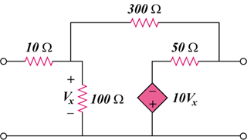

Figure 19.92
For Prob. 19.34.

